**Project Design Phase-II**

**Technology Stack (Architecture & Stack)**

|  |  |
| --- | --- |
| Date | 23-10-2022 |
| Team ID | PNT2022TMID44123 |
| Project Name | **AI-Powered Nutritional Analyzer for Fitness Enthusiasts** |
| Maximum Marks | 4 Marks |

**Technical Architecture:**

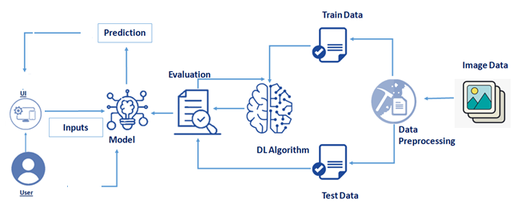

**Front End Back End-IBM cloud Database**

**Table-1: Components & Technologies:**

|  |  |  |  |
| --- | --- | --- | --- |
| **S.No** | **Component** | **Description** | **Technology** |
|  | User Interface | How user interacts with application e.g.  Web UI, Mobile App. | HTML, CSS, JavaScript / Angular Js / React Js etc. |
|  | Application Logic-1 | The application contains the sign in/signs up where the user will login into the main dashboard. | Java / Python |
|  | Application Logic-2 | Dashboard contains the fields like, Capture image, Upload image and retake image. | IBM Watson STT service |
|  | Application Logic-3 | The user can view the nutrient content present in the fruit. | IBM Watson Assistant |
|  | Database | The image data are stored in the MySQL database | MySQL, NoSQL, etc. |
|  | Cloud Database | With use of Database Service on  Cloud, the User data are stored in a well secured Manner | IBM DB2, IBM Cloudant etc. |
|  | File Storage | IBM Block Storage used to store the image data of the user | IBM Block Storage or Other Storage Service or Local Filesystem |
|  | Deep Learning Model | The Deep learning model recognize the image of the fruit and delivers the name of the fruit | Convolutional neural network |

**Table-2: Application Characteristics:**

| **S.No** | **Characteristics** | **Description** | **Technology** |
| --- | --- | --- | --- |
|  | Open-Source Frameworks | Flask Framework in Python is used to implement this Application | Python-Flask |
|  | Security Implementations | This Application Provides high security to the user login data. It can be done by using the  Container Registry in IBM cloud | Container Registry, Kubernetes Cluster |
|  | Scalable Architecture | Nutritional Analyzer is a scalable architecture. We can scale the application whenever there is a need. | Container Registry, Kubernetes Cluster |
|  | Availability | This application will be available to the user at any time | Container Registry, Kubernetes Cluster |
|  | Performance | The performance will be high because there will be no network traffics in the application | Kubernetes Cluster |